Timaflu – Use Case Descriptions
Contents
Timaflu – Use Case Descriptions 1
UC01 Manage manufacturer data 2
UC02 Reorder products 2
UC03 View minimum stock 3
UC04 Check stock 5
UC05 Enter order 6
UC06 View order status 8
UC07 Manage customer data 9
UC08 View collection bins 10
UC09 Pack order 11
UC10 Register collection bin 14
UC11 Complete sub-order 15
UC12 Register delivery 16
UC13 View assigned trips 17
UC14 Look up delivery time 18
UC15 Look up customer phone number 19
UC16 Create invoice 20
UC17 View delivered orders 21
UC18 View outstanding invoices 22
UC19 Register payment 23

UC01 Manage manufacturer data
- Use Case name
Manage manufacturer data
- Brief summary
The purchasing employee adds a manufacturer, edits a manufacturer's data or removes a manufacturer.
- Actors
Purchasing Employee
- Assumptions (precondition)
The purchasing employee is logged in.
- Description (step-by-step plan)
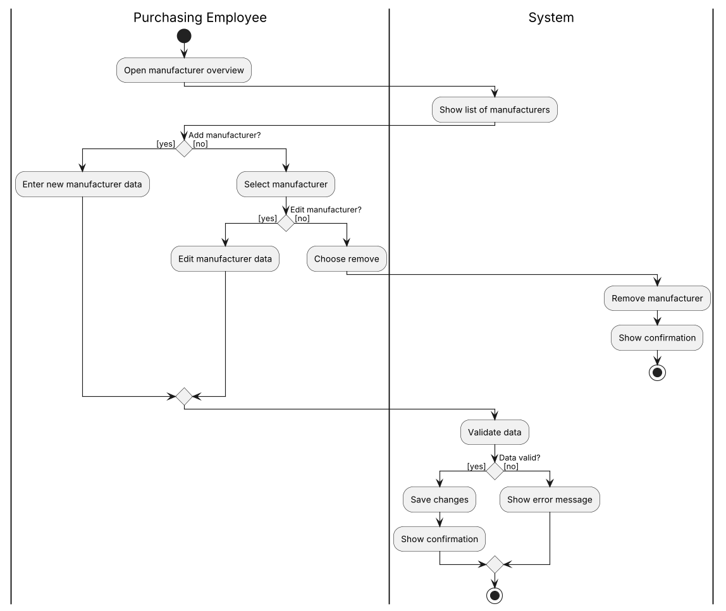
- Exception
The entered data is invalid: the system shows an error message and saves nothing.
- Result (postcondition)
The manufacturer has been added, edited or removed, or nothing has changed because the data was invalid.

UC02 Reorder products
- Use Case name
Reorder products
- Brief summary
The purchasing employee reorders a product. The system selects the cheapest manufacturer and sends the order. If the order is rejected, the system tries the next cheapest manufacturer.
- Actors
Purchasing Employee, Manufacturer
- Assumptions (precondition)
The purchasing employee is logged in. The product exists in the system and has at least one manufacturer.
- Description (step-by-step plan)
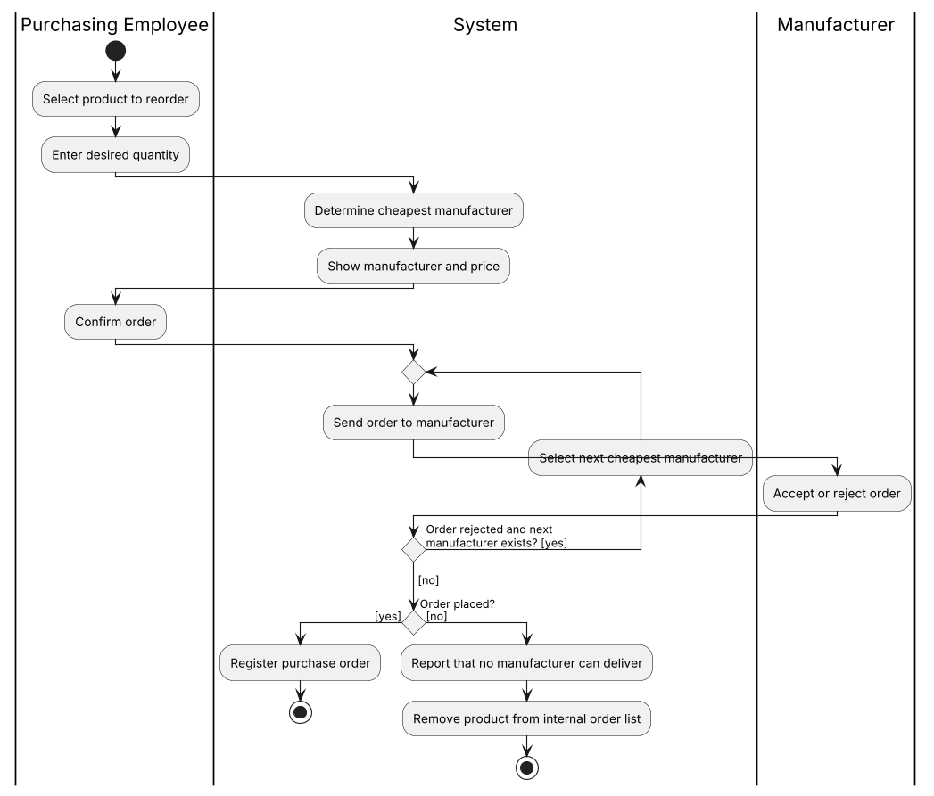
- Exception
No manufacturer accepts the order: the system reports this and removes the product from the internal order list.
- Result (postcondition)
A purchase order has been registered with a manufacturer, or the product has been removed from the internal order list.

UC03 View minimum stock
- Use Case name
View minimum stock
- Brief summary
The purchasing employee views which products are below their minimum stock level.
- Actors
Purchasing Employee
- Assumptions (precondition)
The purchasing employee is logged in. A minimum stock level is recorded for each product.
- Description (step-by-step plan)
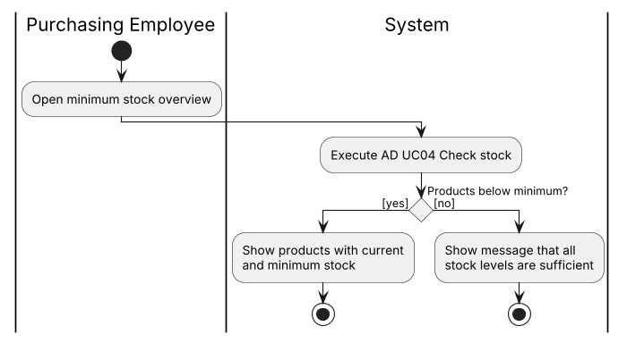
- Exception
No product is below its minimum: the system reports that all stock levels are sufficient.
- Result (postcondition)
The products below minimum stock are shown with their current and minimum stock.

UC04 Check stock
- Use Case name
Check stock
- Brief summary
An employee looks up a product and sees the available stock and locations. If there is not enough stock, a backorder is registered.
- Actors
Purchasing Employee, Sales Employee
- Assumptions (precondition)
The employee is logged in.
- Description (step-by-step plan)
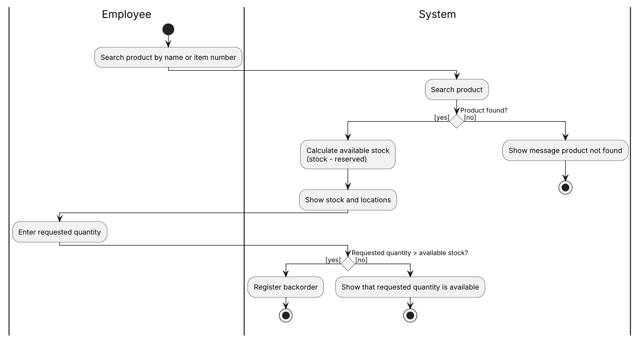
- Exception
Product not found: the system shows a message. Requested quantity exceeds available stock: a backorder is registered.
- Result (postcondition)
The available stock and locations have been shown, and a backorder may have been registered.

UC05 Enter order
- Use Case name
Enter order
- Brief summary
The sales employee takes a customer's order by phone, checks the stock for each product, calculates price and discount and, after approval, schedules the delivery time.
- Actors
Sales Employee
- Assumptions (precondition)
The sales employee is logged in. The customer exists in the system.
- Description (step-by-step plan)
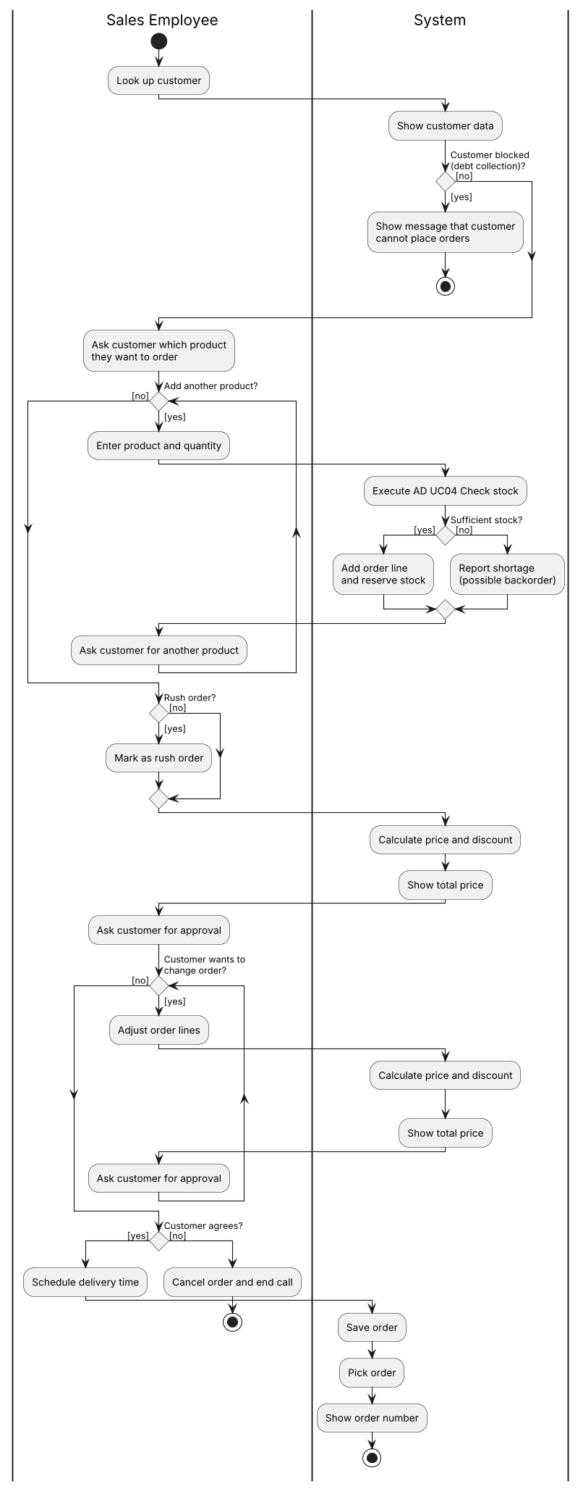
- Exception
The customer is blocked (debt collection): the system reports that the customer cannot place orders. Insufficient stock: the system reports the shortage (possible backorder). The customer does not agree: the order is cancelled.
- Result (postcondition)
The order has been saved with an order number, reserved stock and a delivery time, or the order has been cancelled.

UC06 View order status
- Use Case name
View order status
- Brief summary
The sales employee looks up an order and views its status, order lines, backorders and delivery time.
- Actors
Sales Employee
- Assumptions (precondition)
The sales employee is logged in.
- Description (step-by-step plan)
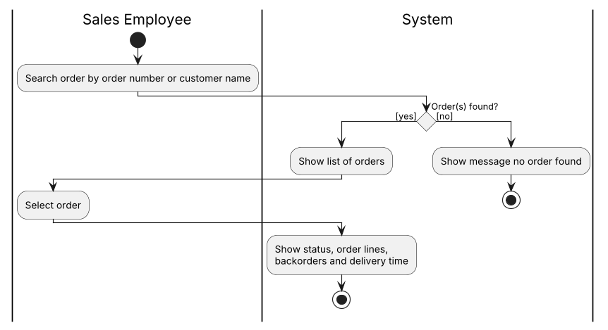
- Exception
No order found: the system shows a message.
- Result (postcondition)
The status and details of the selected order have been shown.

UC07 Manage customer data
- Use Case name
Manage customer data
- Brief summary
The sales employee adds a customer (optionally with a one-time 10% acquisition discount), edits customer data or deactivates a customer.
- Actors
Sales Employee
- Assumptions (precondition)
The sales employee is logged in.
- Description (step-by-step plan)
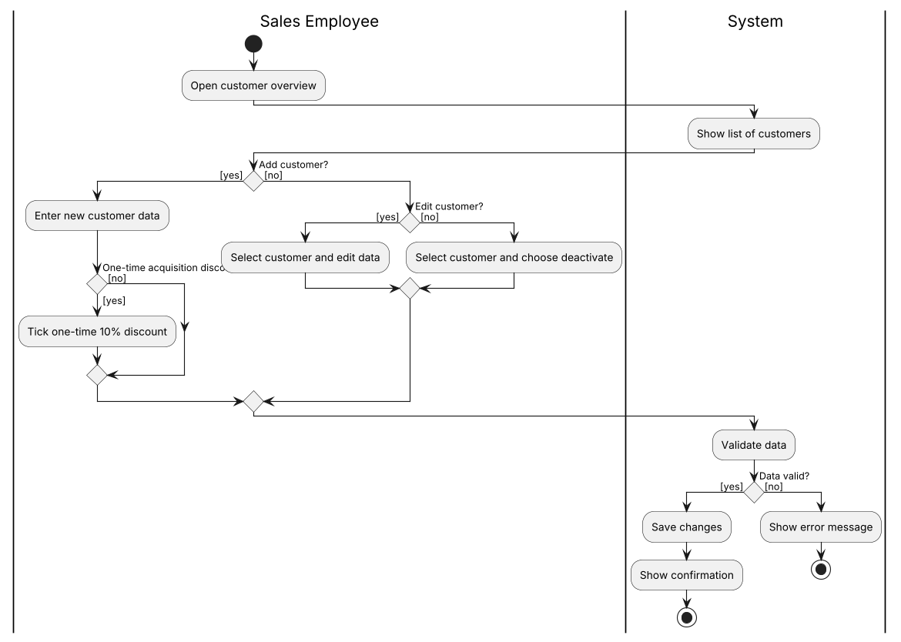
- Exception
The entered data is invalid: the system shows an error message and saves nothing.
- Result (postcondition)
The customer has been added, edited or deactivated, or nothing has changed because the data was invalid.

UC08 View collection bins
- Use Case name
View collection bins
- Brief summary
The distribution employee views which orders have collection bins, how many bins each has and whether the order is complete.
- Actors
Distribution Employee
- Assumptions (precondition)
The distribution employee is logged in.
- Description (step-by-step plan)
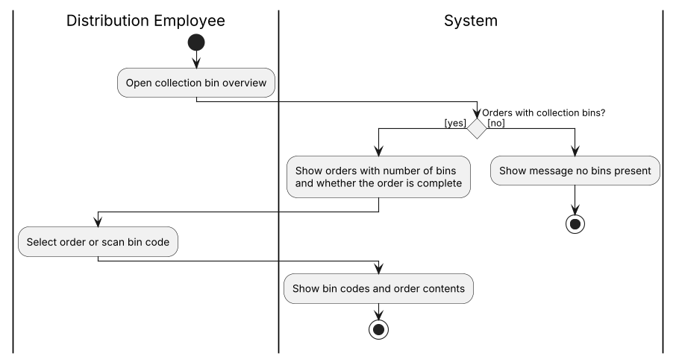
- Exception
There are no collection bins: the system shows a message.
- Result (postcondition)
The bin codes and contents of the selected order have been shown.

UC09 Pack order
- Use Case name
Pack order
- Brief summary
The distribution employee packs a complete order into boxes. The system prints the labels, updates the order status and assigns a trip.
- Actors
Distribution Employee
- Assumptions (precondition)
The distribution employee is logged in. All sub-orders of the order have been collected.
- Description (step-by-step plan)
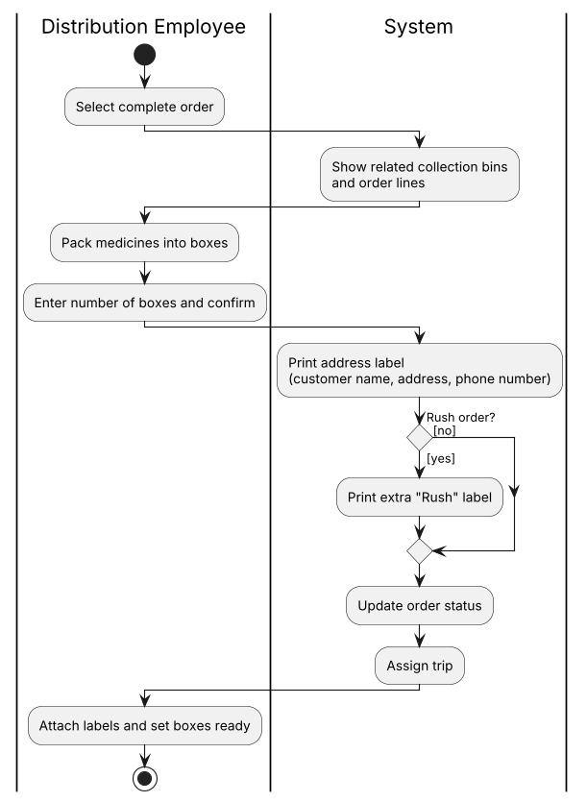
- Exception
N/A
- Result (postcondition)
The order has been packed and labelled, its status has been updated and a trip has been assigned.

UC10 Register collection bin
- Use Case name
Register collection bin
- Brief summary
The warehouse robot scans an empty collection bin and the system links the bin to a sub-order.
- Actors
Warehouse Robot
- Assumptions (precondition)
The robot has received a sub-order.
- Description (step-by-step plan)
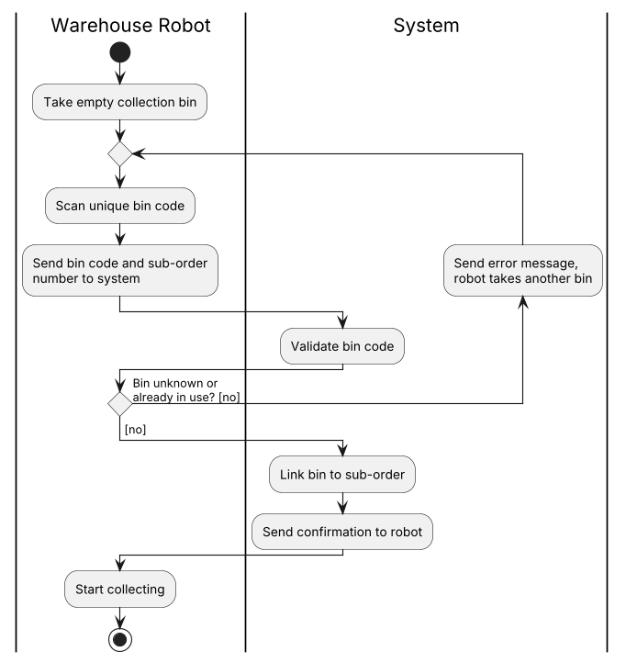
- Exception
The bin code is unknown or already in use: the system sends an error message and the robot takes another bin.
- Result (postcondition)
The collection bin is linked to the sub-order and the robot starts collecting.

UC11 Complete sub-order
- Use Case name
Complete sub-order
- Brief summary
The warehouse robot reports a sub-order as collected. The system reduces the stock, updates the order status and sends a new sub-order if there is one.
- Actors
Warehouse Robot
- Assumptions (precondition)
The sub-order is linked to a collection bin.
- Description (step-by-step plan)
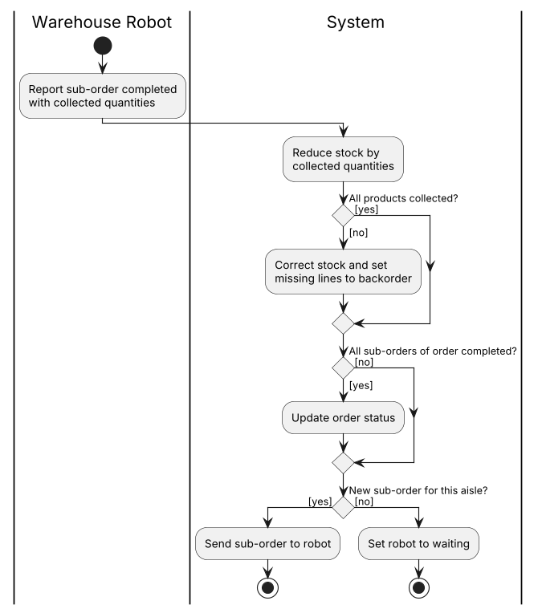
- Exception
Not all products were collected: the system corrects the stock and sets the missing lines to backorder.
- Result (postcondition)
The stock has been updated, the order status may have been updated, and the robot has a new sub-order or is waiting.

UC12 Register delivery
- Use Case name
Register delivery
- Brief summary
The courier delivers an order, the customer signs digitally and the system updates the order status. If the customer is not present, the courier calls the customer.
- Actors
Courier, Customer
- Assumptions (precondition)
The courier is logged in and the order is part of an assigned trip.
- Description (step-by-step plan)
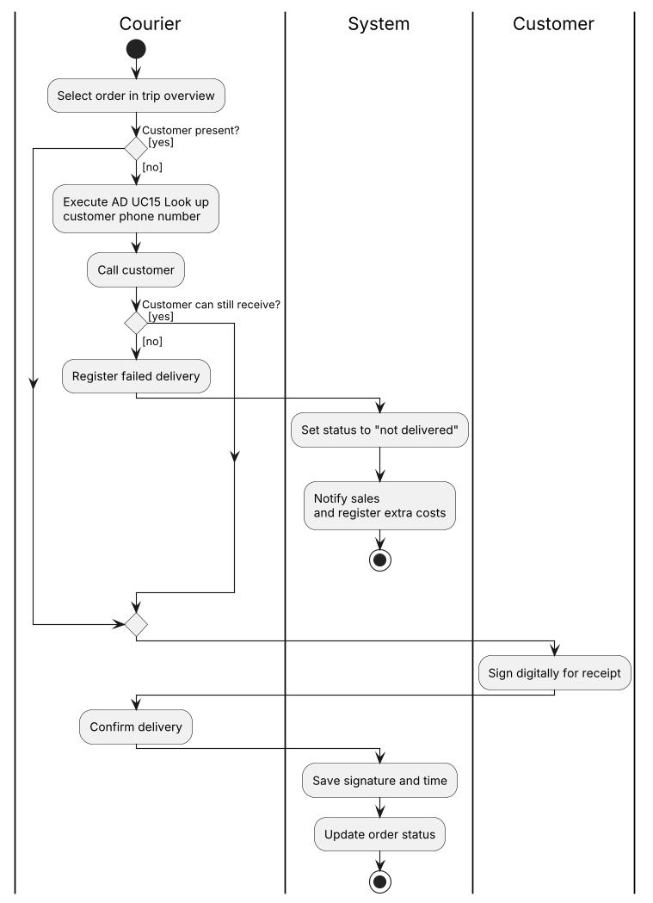
- Exception
The customer is not present and cannot receive the order later: the courier registers a failed delivery. The system sets the status to "not delivered", notifies sales and registers extra costs.
- Result (postcondition)
The delivery has been registered with signature and time, or registered as failed.

UC13 View assigned trips
- Use Case name
View assigned trips (including rush)
- Brief summary
The courier reports as available and views the assigned trips, rush trips first.
- Actors
Courier
- Assumptions (precondition)
The courier is logged in.
- Description (step-by-step plan)
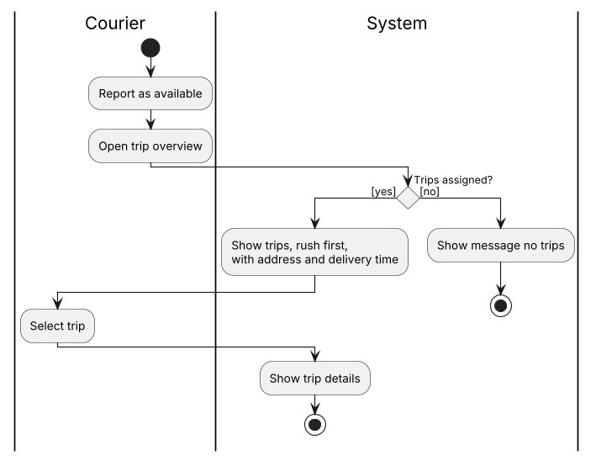
- Exception
No trips have been assigned: the system shows a message.
- Result (postcondition)
The trips and the details of the selected trip have been shown.

UC14 Look up delivery time
- Use Case name
Look up delivery time
- Brief summary
The courier looks up the agreed delivery date and part of day for an order.
- Actors
Courier
- Assumptions (precondition)
The courier is logged in.
- Description (step-by-step plan)
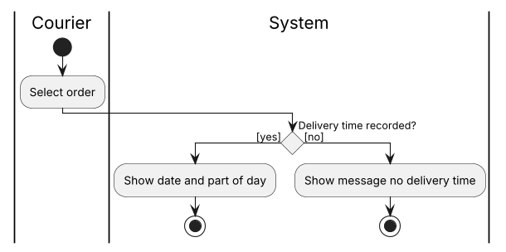
- Exception
No delivery time has been recorded: the system shows a message.
- Result (postcondition)
The delivery date and part of day have been shown.

UC15 Look up customer phone number
- Use Case name
Look up customer phone number
- Brief summary
The courier looks up the contact person and phone number of the customer for an order.
- Actors
Courier
- Assumptions (precondition)
The courier is logged in.
- Description (step-by-step plan)
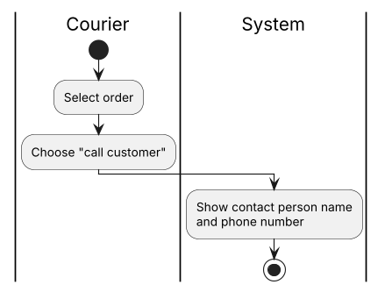
- Exception
N/A
- Result (postcondition)
The contact person's name and phone number have been shown.

UC16 Create invoice
- Use Case name
Create invoice
- Brief summary
The administration employee starts the weekly invoicing. For each customer, the system bundles the delivered orders into an invoice and sends it to the customer.
- Actors
Administration Employee, Customer
- Assumptions (precondition)
The administration employee is logged in.
- Description (step-by-step plan)
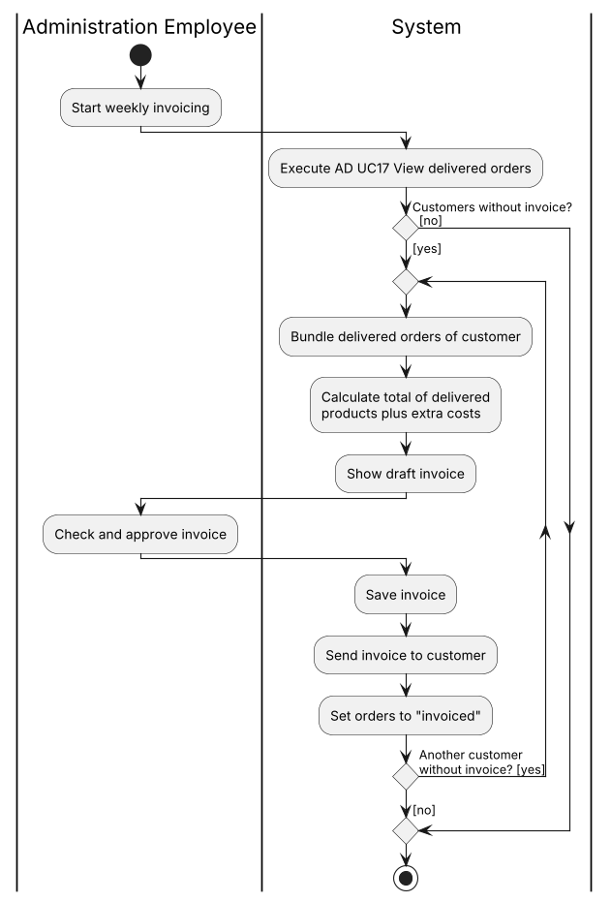
- Exception
There are no customers with delivered, uninvoiced orders: no invoice is created.
- Result (postcondition)
An invoice has been saved and sent for each customer, and the orders are set to "invoiced".

UC17 View delivered orders
- Use Case name
View delivered orders
- Brief summary
The administration employee views the delivered orders that have not been invoiced yet.
- Actors
Administration Employee
- Assumptions (precondition)
The administration employee is logged in.
- Description (step-by-step plan)
[image: AD UC17 View delivered orders]
- Exception
There are no delivered, uninvoiced orders: the system shows a message.
- Result (postcondition)
The order lines and extra costs of the selected order have been shown.

UC18 View outstanding invoices
- Use Case name
View outstanding invoices
- Brief summary
The administration employee views unpaid invoices and takes action based on how long they have been open: a reminder, a payment plan or the debt collection agency.
- Actors
Administration Employee, Customer
- Assumptions (precondition)
The administration employee is logged in.
- Description (step-by-step plan)
- 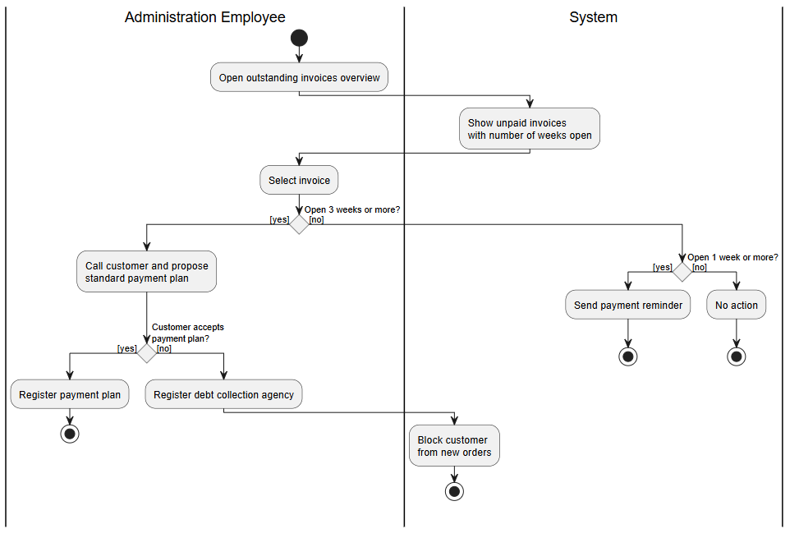Exception
The customer does not accept the payment plan: a debt collection agency is registered and the customer is blocked from new orders.
- Result (postcondition)
A reminder has been sent, a payment plan registered, a debt collection agency engaged, or no action was needed.

UC19 Register payment
- Use Case name
Register payment
- Brief summary
The administration employee registers a received payment for an invoice.
- Actors
Administration Employee
- Assumptions (precondition)
The administration employee is logged in. The invoice is outstanding.
- Description (step-by-step plan)
- 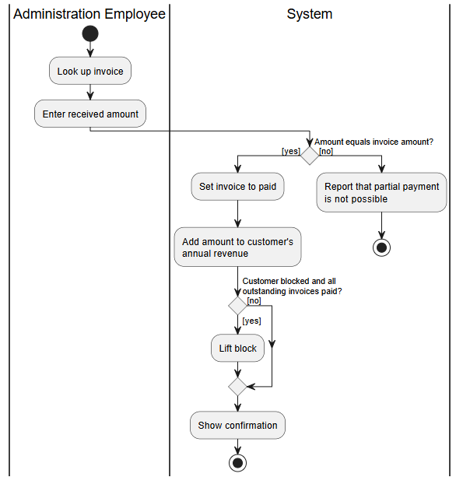Exception
The amount does not equal the invoice amount: the system reports that partial payment is not possible.
- Result (postcondition)
The invoice is set to paid, the amount is added to the customer's annual revenue and any block has been lifted.

